- NeelSuono... Le segnalazioni della Luce (Bhag Baba)

Sai Bhajana Bina

http://it.youtube.com/watch?v=SN4dFyZNKco

Sai Bhajana Bina Sukha Shaanti Nahi

Hari Naam Bina Aanand Nahi

Prema Bhakthi Bina Uddhaar Nahi

Guru Seva Bina Nirvaan Nahi ...Sai Bhajana

Japa Dhyaana Bina Samyog Nahi

Prabhu Darsa Bina Prajnan Nahi

Daya Dharma Bina Sat Karma Nahi

Bhagawaan Bina Koyi Apna Nahi

Sai Ram Bina Paramaatma Nahi

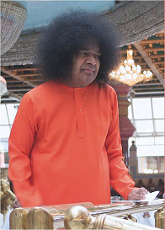

Without singing Sai Bhajan, it is not possible to find peace and happiness.
Without worshipping Shree Krishna it is not possible to gain bliss.
Without love, devotion and detachment liberation is not possible.
Without service to the divine teacher salvation is not possible. Without meditation and repetition of God's name Samadhi or union with god is not possible.
Without a desire to realize god, supreme knowledge cannot be attained.
Without kindness and right conduct no act can be called a good act.
There is no one that we can call our own except god.
There is no Lord except the Supreme Lord Of Lords, Sai Nath

